Standard | Items:
G-C0
G-CO A1  Know precise definitions of angle, circle, perpendicular line, parallel line, and line segment, based on the undefined notions of point, line, distance along a line, and distance around a circular arc. | 3.0  Match the definition with the appropriate term.  A1.  Angle ______  Circle ______  Parallel line ______  Line segment _____  Perpendicular line _______  a. Coplanar lines that do not intersect.  b. A set of points that consisting of two different rays that have the same endpoint.  c. Part of a line that consists of two points, called endpoints, and all points on the line between the endpoints.  d. Two lines that intersect to form a right angle.  e. The set of all points in a plane that are equidistant from a given a point.
2.0
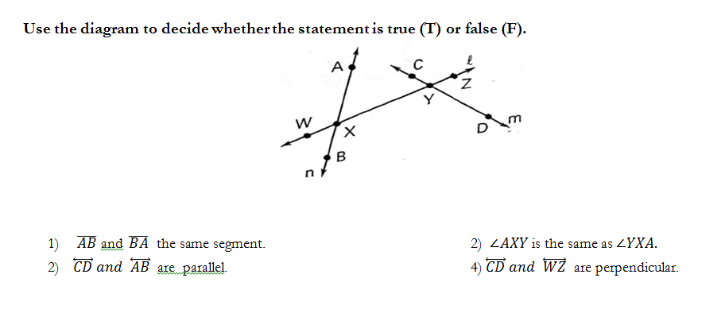

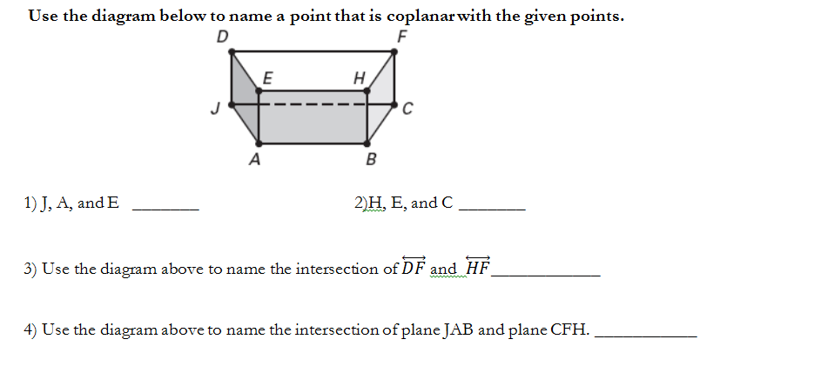

GCOC9  G-CO  Prove theorems about lines and angles. Theorems include: vertical angles are congruent; when a transversal crosses parallel lines, alternate interior angles are congruent and corresponding angles are congruent; points on a perpendicular bisector of a line segment are exactly those equidistant from the segment's endpoints. | 3.0  A2  - Prove that vertical angles are congruent. Include a diagram with your proof.  - Prove alternate interior angles are congruent. Include a diagram with your proof.  - Prove corresponding angles are congruent include a diagram with your proof.  2.0  1)Find the measure of missing angles.  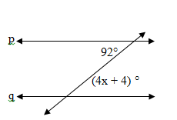  2)  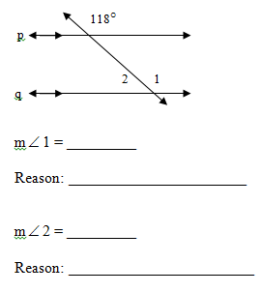  2) A polygon is regular if it is equilateral.  if-then:  converse:  Inverse:  3)
CO.C10  G-CO  Prove theorems about triangles. Theorems include: measures of interior angles of a triangle sum to 180°; base angles of isosceles triangles are congruent; the segment joining midpoints of two sides of a triangle is parallel to the third side and half the length; the medians of a triangle meet at a point. | 3.0  A10.  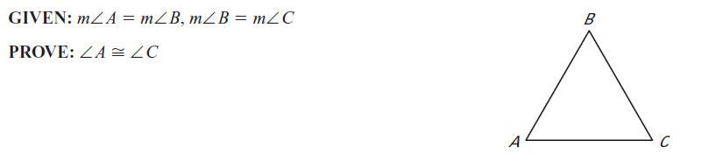  2.0  A10  - Find the value of x.  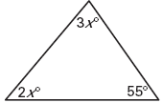  2)  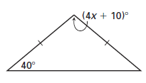  3)  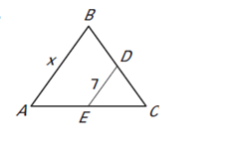
CCSS.MATH.CONTENT.HSG.CO.B.6  Use geometric descriptions of rigid motions to transform figures and to predict the effect of a given rigid motion on a given figure; given two figures, use the definition of congruence in terms of rigid motions to decide if they are congruent. | 3.0
 | 2.0
CCSS.MATH.CONTENT.HSG.CO.B.7  Use the definition of congruence in terms of rigid motions to show that two triangles are congruent if and only if corresponding pairs of sides and corresponding pairs of angles are congruent. | 3.0
 | 2.0
CCSS.MATH.CONTENT.HSG.CO.B.8  Explain how the criteria for triangle congruence (ASA, SAS, and SSS) follow from the definition of congruence in terms of rigid motions. | 3.0
 | 2.0
CO.C.11  G-CO  Prove theorems about parallelograms. Theorems include: opposite sides are congruent, opposite angles are congruent, the diagonals of a parallelogram bisect each other, and conversely, rectangles are parallelograms with congruent diagonals. | 3.0
2.0
1) A polygon is regular if it is equilateral.
if-then:
converse:
Inverse:

2)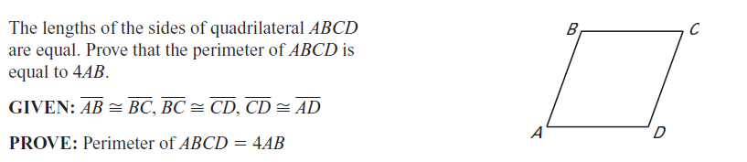
Use congruence and similarity criteria for triangles to solve problems and to prove relationships in geometric figures. | 3.0
COD12  Make geometric constructions  Make formal geometric constructions with a variety of tools and methods (compass and straightedge, string, reflective devices, paper folding, dynamic geometric software, etc.).Copying a segment; copying an angle; bisecting a segment; bisecting an angle; constructing perpendicular lines, including the perpendicular bisector of a line segment; and constructing a line parallel to a given line through a point not on the line. | 2.0  G-CO  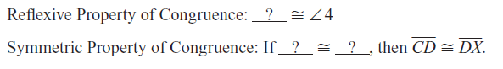  A1  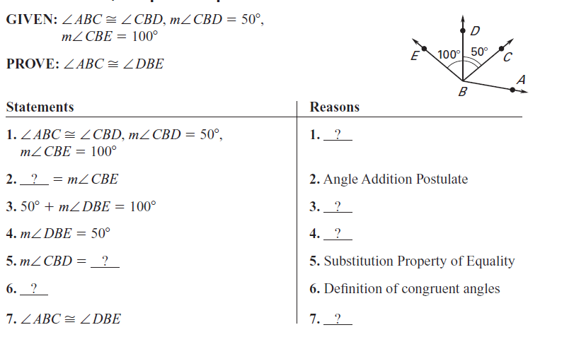
 | Activity attatched.
SRTA2

COA2
Given two figures, use the definition of similarity in terms of similarity transformations to decide if they are similar; explain using similarity transformations the meaning of similarity for triangles as the equality of all corresponding pairs of angles and the proportionality of all corresponding pairs of sides.

 | 3.0
 | 2.0
3.0

2) A polygon is regular if it is equilateral.
if-then:
converse:
inverse:

 | 2.0
HSG CO.A.3  Given a rectangle, parallelogram, trapezoid, or regular polygon, describe the rotations and reflections that carry it onto itself. | 3.0
 | 2.0
HSG.A.4  Develop definitions of rotations, reflections, and translations in terms of angles, circles, perpendicular lines, parallel lines, and line segments. | 3.0
 | 2.0
HSG.CO.A.5  Given a geometric figure and a rotation, reflection, or translation, draw the transformed figure using, e.g., graph paper, tracing paper, or geometry software. Specify a sequence of transformations that will carry a given figure onto another. | 3.0
 | 2.0

GPEB6  Find the point on a directed line segment between two given points that partitions the segment in a given ratio. | 3.0

GPEB7  G-GPE  Use coordinates to compute perimeters of polygons and areas of triangles and rectangles, e.g., using the distance formula.* | 3.0  D1.  - Determine the area of a rectangle with vertices at (2,2) , (2,4), (-1,4) , (-1,2).  - Determine the area of a triangle whose vertices are located at: (1,7), (-10,3) and (-5,-2).  - Determine the perimeter of a polygon with the given vertices:  - (-1,1),(4,9),(5,2),(-3,10), (0,-7)  D2.  - Given 6x-15 = x-5  Prove: x=2  D3. State the properties shown below  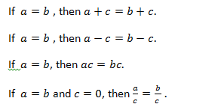
2.0
Find the distance of the segments below:
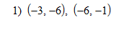
2)
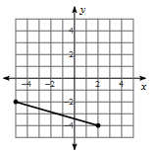
D2.

